Third Grade November Newsletter

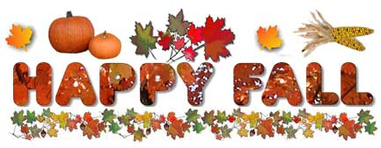

Dear Families,

It is hard to believe that the first nine weeks of school are already over! We enjoyed meeting with each of you to discuss your child’s academic progress during the first quarter conferences. Continue to encourage your child to come to school each day prepared for a day of learning and academic success!

Here is what we plan to cover this month:

Literacy: In literacy, the students will continue to practice reading instruction through independent and guided reading. The students will work on using text features to summarize the main ideas of informational texts. Students will also focus on strengthening specific skills such as cause and effect, drawing conclusions, and making inferences when reading informational text. Be sure your child reads DAILY! This is so important for all students to increase reading fluency and comprehension. In addition, the students will display their understanding of informational texts by creating their own expert pieces of writing.

Math: Students will continue to study addition, subtraction and problem solving. We will then begin our multiplication and division unit. It’s imperative that students are practicing addition and subtraction facts daily at home to review basic math facts. We have noticed that errors have been made in solving problems because many students have forgotten, or are taking time to count on their fingers, to figure out the answer. Please support this at home by using flashcards or visiting interactive websites that practice addition and subtraction facts, such as http://www.factmonster.com/math/flashcards.html.
Math Flashcards - Fact Monster
www.factmonster.comPractice your math facts with these free online math flashcards. Find addition, subtraction, multiplication and division flashcards, from basic math facts to 3-digit ...

Social Studies: The students will complete the current study of communities. We will then study
the following concepts:
o Local communities can develop differently from each other over time.
o People, events and ideas in history may have changed people and communities over time.
o Immigration, the Civil Rights Movement, the Industrial Revolution and Women’s Suffrage have changed communities over time.
o Technology has changed communication and transportation.
o Diverse cultures may bring changes within communities.
o Many cultures use artistic expression to show their beliefs and values within a community.
o Historical narratives and other non-fiction texts from a variety of perspectives can be used to learn about history and culture.

Science: We will begin studying the major components and patterns observed in the earth/moon/sun system.

Please mark your calendars with the following important dates:

Tuesday 11/7 - Kids Voting
Thursday 11/9 - Report Cards Distributed
Friday 11/10 - Veterans’ Day HOLIDAY
Wednesday 11/15 - Make-Up Pictures
Friday 11/17 - Character Education Assembly
Wednesday 11/22 - Friday 11/24 - Thanksgiving Break
Monday 11/27 - Fire Safety Program

We hope everyone has a wonderful Thanksgiving! Please let us know if you have any questions or concerns regarding your child.

The Third Grade Team

